CREATE TABLE IF NOT EXISTS Supplier

(

SNr VARCHAR(4) CHECK (SNr REGEXP 'S[0-9]{3}' ),

SName VARCHAR(50) UNIQUE,

DateofBusiness DATE,

City VARCHAR(50) CHECK ( City REGEXP ('^[A-Z]')),

CONSTRAINT supplier_pkey PRIMARY KEY (SNr)

);

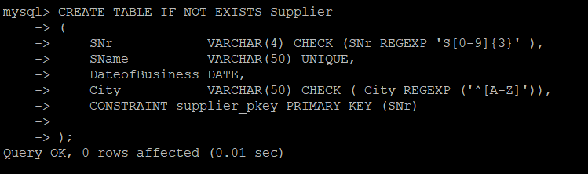

CREATE TABLE IF NOT EXISTS Article

(

ANr VARCHAR(4) CHECK (ANr REGEXP 'A[0-9]{2}' ),

AName VARCHAR(50) UNIQUE,

Color VARCHAR(10),

Weight INT,

City VARCHAR(50),

CONSTRAINT article_pkey PRIMARY KEY (ANr),

CONSTRAINT article_color_check CHECK (Color IN ('WHITE', 'BLACK', 'RED'))

);

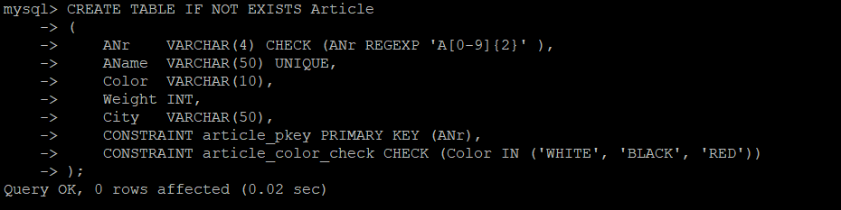

CREATE TABLE IF NOT EXISTS Delivery

(

SNr VARCHAR(4),

ANr VARCHAR(4),

Qty INT,

CONSTRAINT article_fkey FOREIGN KEY (ANr) REFERENCES Article (ANr),

CONSTRAINT supplier_fkey FOREIGN KEY (SNr) REFERENCES Supplier (SNr),

CONSTRAINT delivery_pkey PRIMARY KEY (SNr, ANr)

);

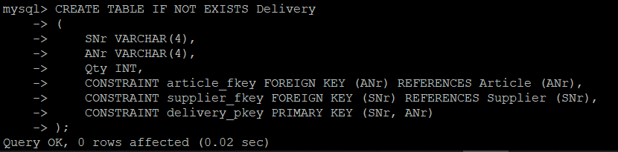

INSERT INTO Supplier

VALUES ('S001', 'KENSTAR', STR_TO_DATE('01/01/2002', '%d/%m/%Y'), 'Chennai'),

('S002', 'SAMSUNG', STR_TO_DATE('12/10/2001', '%d/%m/%Y'), 'Cbe'),

('S003', 'ELGI', STR_TO_DATE('20/02/1999', '%d/%m/%Y'), 'Cbe'),

('S004', 'PHILIPS', STR_TO_DATE('10/12/1999', '%d/%m/%Y'), 'Delhi');

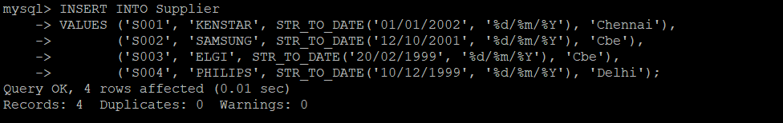

INSERT INTO Article

VALUES ('A01', 'MOBILE', 'BLACK', 100, 'Cbe'),

('A02', 'MICROWAVE', 'WHITE', 1500, 'Bombay'),

('A03', 'AIR COOLER', 'WHITE', 2000, 'Cbe'),

('A04', 'REFRIGIRATOR', 'RED', 10000, 'Delhi');

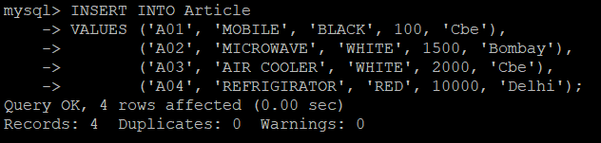

INSERT INTO Delivery

VALUES ('S003', 'A01', 1000),

('S002', 'A02', 200),

('S003', 'A02', 500),

('S004', 'A03', 10),

('S002', 'A04', 50),

('S003', 'A03', 25),

('S001', 'A02', 55),

('S001', 'A03', 200),

('S001', 'A04', 78),

('S001', 'A01', 67);

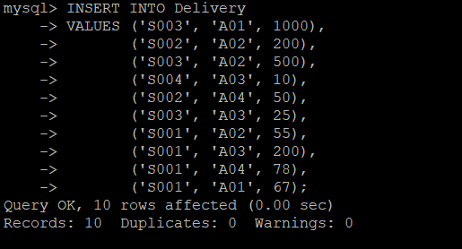

1)SELECT SNr, ANr

FROM Delivery

WHERE SNr IN (SELECT SNr FROM Delivery GROUP BY SNr HAVING COUNT(*) > 1);

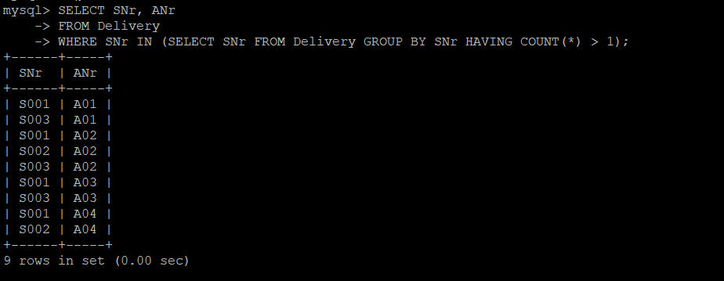

2)SELECT ANr, Qty

FROM Delivery

WHERE ANr IN (SELECT ANr

FROM (SELECT ANr, RANK() OVER (ORDER BY City) AS ranking FROM Article) selection

WHERE ranking = 1);

3)SELECT DISTINCT SNr

FROM Delivery

WHERE ANr IN (

SELECT DISTINCT ANr

FROM Delivery

WHERE SNr IN (SELECT DISTINCT SNr

FROM Delivery

INNER JOIN Article ON Delivery.ANr = Article.ANr AND Article.Color = 'RED'));

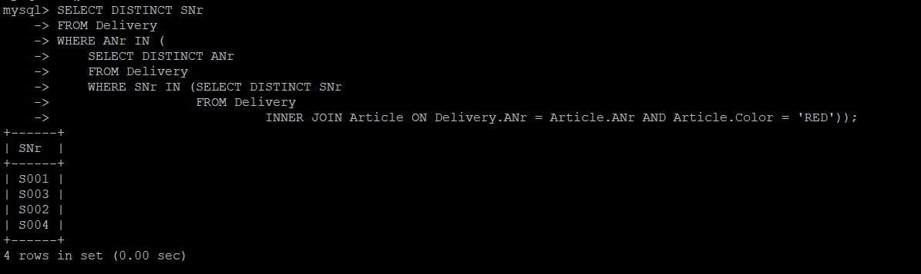

4)SELECT ANr

FROM Delivery

INNER JOIN Article A USING (ANr)

INNER JOIN Supplier S USING (SNr)

WHERE A.City = 'Cbe'

AND S.City = 'Cbe';

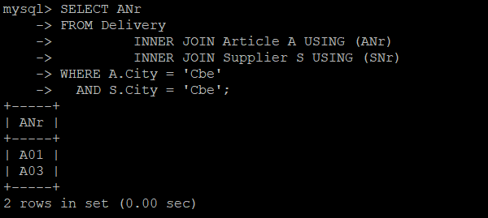

5)

6)ALTER TABLE Article

DROP CONSTRAINT article_color_check;

ALTER TABLE Article

ADD CONSTRAINT article_color_check CHECK (Color IN ('WHITE', 'BLACK', 'RED', 'GREEN'));

INSERT INTO Article VALUE ('A05', 'WASHING MACHINE', 'GREEN', 20000, 'Cbe');

7)SELECT SNr, DateofBusiness

FROM Delivery

INNER JOIN Article A USING (ANr)

INNER JOIN Supplier S USING (SNr)

WHERE A.Color = 'BLACK';

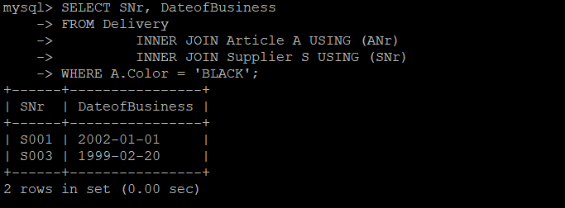

8)SELECT SName

FROM Supplier

WHERE SNr IN (SELECT SNr

FROM (SELECT SNr, RANK() OVER (ORDER BY COUNT(DISTINCT ANr) DESC) AS ranking

FROM Delivery

GROUP BY SNr) selection

WHERE ranking = 1);

9)SELECT SName

FROM Supplier

WHERE SNr IN (SELECT SNr

FROM (SELECT SNr, RANK() OVER (ORDER BY SUM(Qty) DESC) AS ranking

FROM Delivery

GROUP BY SNr) selection

WHERE ranking = 1);

10)SELECT SName

FROM Supplier

WHERE SNr IN (SELECT SNr

FROM (SELECT SNr, RANK() OVER (ORDER BY SUM(Qty) DESC) AS ranking

FROM Delivery

GROUP BY SNr) selection

WHERE ranking = 2);

11)SELECT *

FROM Delivery

WHERE SNr IN (SELECT SNr FROM Supplier WHERE City IN (SELECT City FROM Supplier GROUP BY City HAVING COUNT(City) > 1));

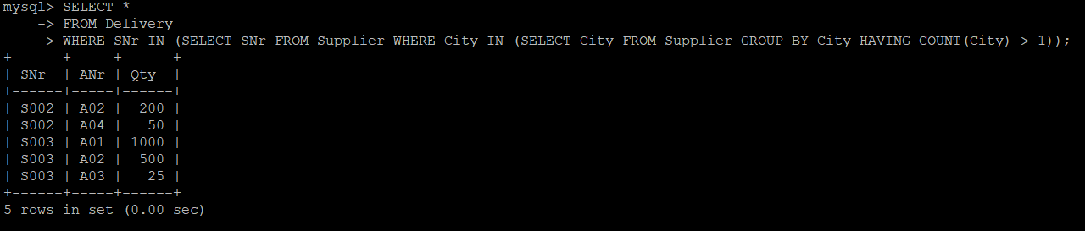

12)SELECT *

FROM Delivery

WHERE SNr IN (SELECT SNr FROM Supplier WHERE City IN (SELECT City FROM Supplier GROUP BY City HAVING COUNT(City) = 1));

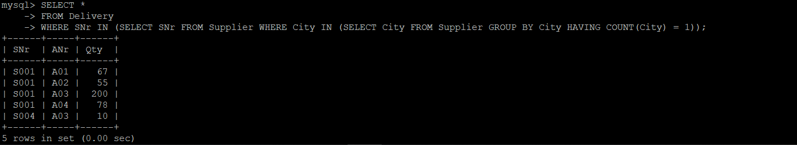

13)SELECT SNR, DateofBusiness

FROM Supplier

WHERE SNr IN (SELECT SNr FROM Delivery GROUP BY SNr HAVING SUM(Qty) = 250);

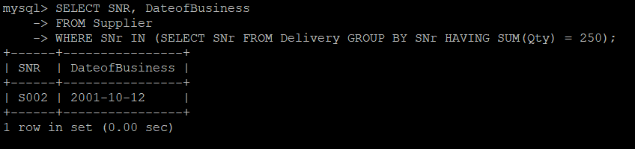

14)SELECT A.*

FROM Delivery

INNER JOIN Article A USING (ANr)

INNER JOIN Supplier S USING (SNr)

WHERE S.SName = 'ELGI';

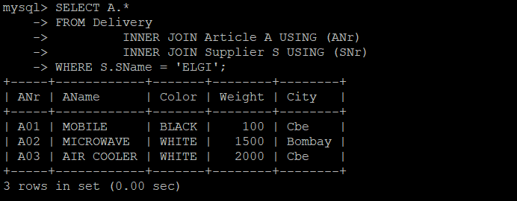

15)SELECT A.*

FROM Article A

WHERE A.ANr IN (SELECT ANr

FROM (SELECT ANr, RANK() OVER (ORDER BY SUM(Qty) DESC) AS ranking

FROM Delivery

GROUP BY ANr) selection

WHERE ranking = 1);

16)SELECT DISTINCT S.City

FROM Delivery

INNER JOIN Article A USING (ANr)

INNER JOIN Supplier S USING (SNr)

WHERE A.AName = 'MICROWAVE';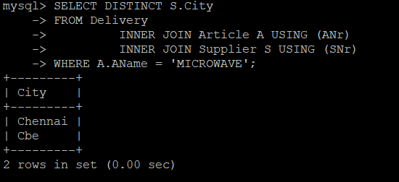

17)SELECT S.City

FROM Delivery

INNER JOIN Article A USING (ANr)

INNER JOIN Supplier S USING (SNr)

WHERE A.AName = 'MICROWAVE'

GROUP BY S.City

HAVING COUNT(*) > 1;

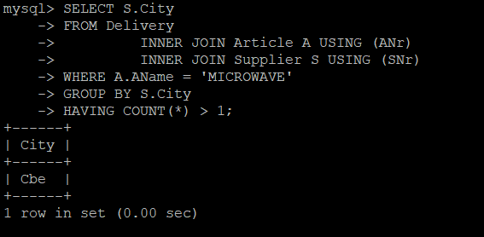

18)SELECT SNr, AName, Weight, Color

FROM Delivery

INNER JOIN Article A USING (ANr)

INNER JOIN Supplier S USING (SNr)

WHERE (A.Color, SNr) IN (

SELECT A.Color, SNr

FROM Delivery

INNER JOIN Article A USING (ANr)

INNER JOIN Supplier S USING (SNr)

GROUP BY A.Color, SNr

HAVING COUNT(SNr) > 1)

ORDER BY SNr;

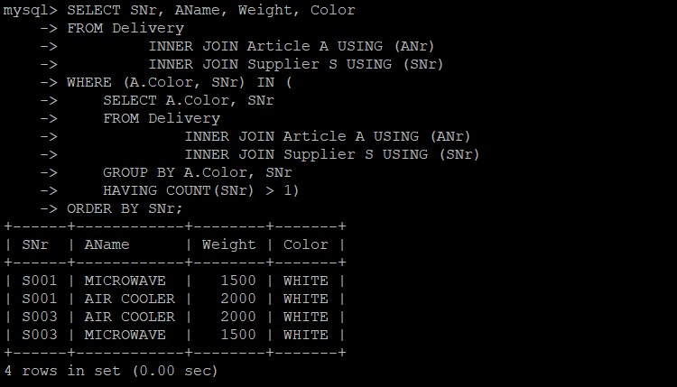

19)SELECT *

FROM Delivery

INNER JOIN Supplier S USING (SNr)

INNER JOIN Article A USING (ANr)

ORDER BY SNr;

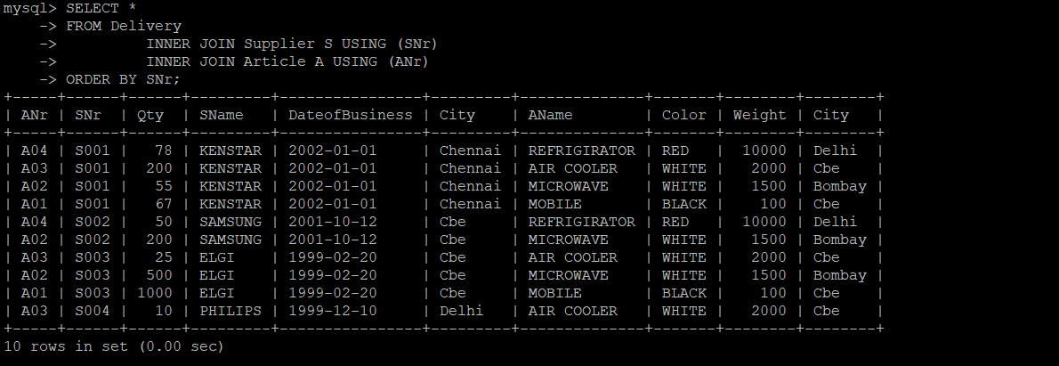

20)SELECT A.*

FROM Delivery

INNER JOIN Article A USING (ANr)

ORDER BY SNr;

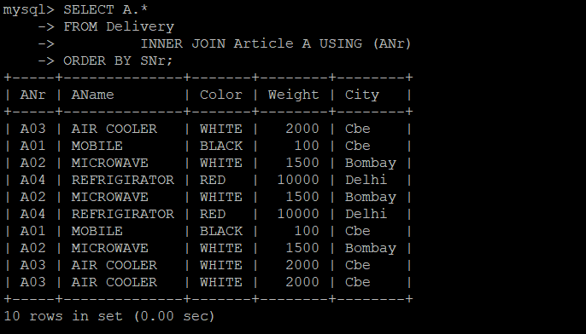

21)SELECT A.*

FROM Delivery

INNER JOIN Article A USING (ANr)

WHERE SNr = (SELECT SNr FROM Supplier ORDER BY SName DESC LIMIT 1);

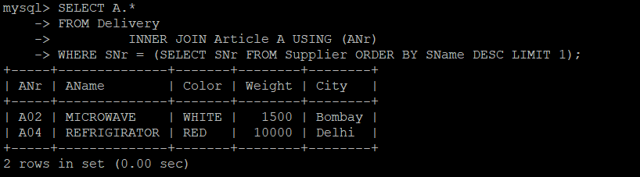

22)SELECT DISTINCT SName

FROM Delivery

INNER JOIN Supplier S USING (SNr)

INNER JOIN Article A USING (ANr)

WHERE A.AName = 'MICROWAVE';

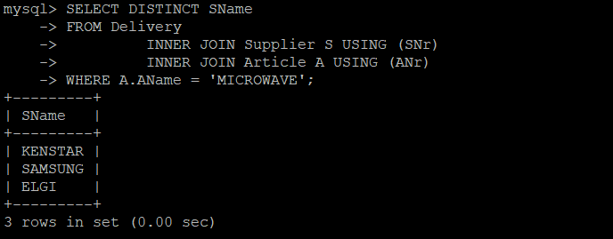

23)SELECT SName

FROM Supplier

WHERE SNr NOT IN (SELECT DISTINCT SNr

FROM Delivery

INNER JOIN Article ON Delivery.ANr = Article.ANr AND Article.AName = 'MOBILE');

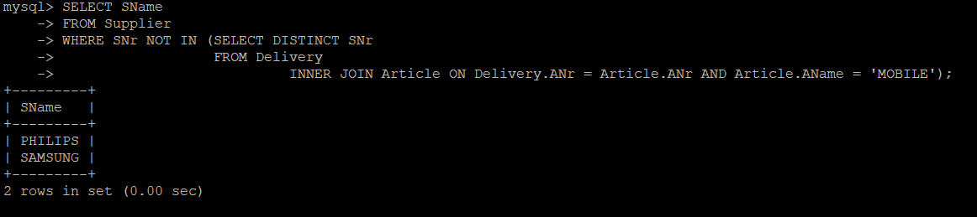

24)SELECT DISTINCT SName

FROM Delivery

INNER JOIN Supplier S USING (SNr)

INNER JOIN Article A USING (ANr)

GROUP BY SName

HAVING COUNT(DISTINCT ANr) = (SELECT COUNT(*) FROM Article);

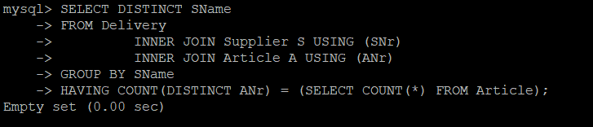

25)SELECT DISTINCT SName

FROM Supplier

JOIN Delivery USING (SNr)

WHERE ANr IN (SELECT ANr FROM Delivery WHERE SNr = 'S002');

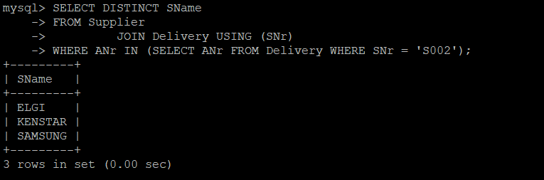

26)SELECT SNr, City

FROM Supplier

WHERE City IN (Select City FROM Supplier GROUP BY City HAVING COUNT(*) > 1);

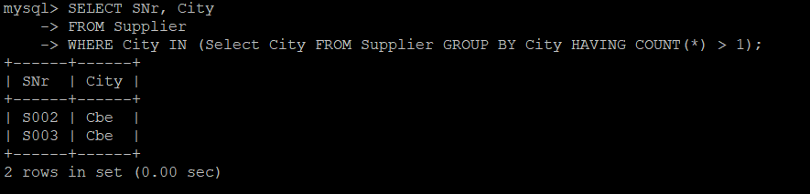

27)SELECT ANr

FROM Article

WHERE ANr NOT IN (SELECT DISTINCT D.ANr

FROM Supplier

INNER JOIN Delivery D on Supplier.SNr = D.SNr AND Supplier.City = 'Delhi');

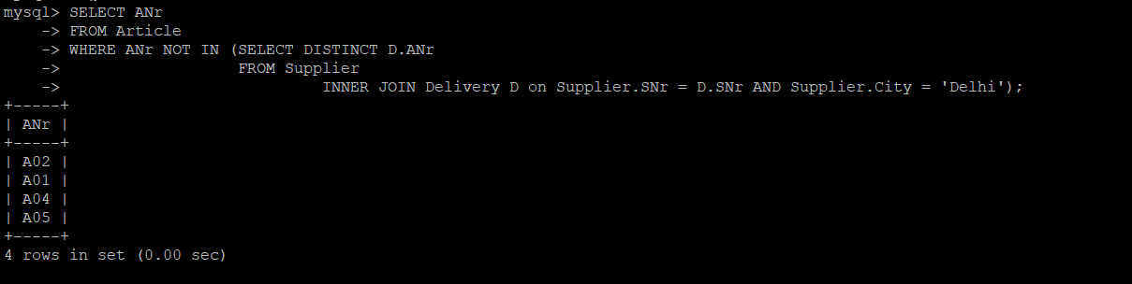

28)SELECT SNr

FROM Supplier

WHERE City = (Select City FROM Supplier ORDER BY City LIMIT 1);

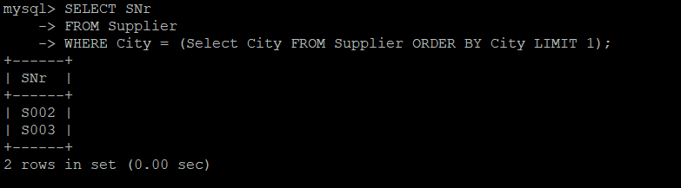

29)SELECT ANr

FROM Article

WHERE Weight > 2000

AND ANr IN (SELECT ANr FROM Delivery GROUP BY ANr HAVING COUNT(ANr) IN (SELECT COUNT(SNr) FROM Supplier));



30)SELECT AName

FROM Article

INNER JOIN Delivery USING (ANr)

WHERE ANr NOT IN (SELECT DISTINCT ANr FROM Delivery WHERE SNr != 'S001');

